

[[Bansilal Ramnath Agarwal Charitable Trust's](http://www.viit.ac.in/index.php)Vishwakarma Institute Of Information Technology](http://www.viit.ac.in/index.php)

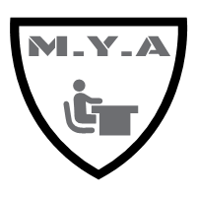

Mark Your Attendance

Software Specification Requirements

Table of Contents

1. Introduction

*1.1 Purpose*

*1.2 Scope*

*1.3 Definitions, Acronyms, and Abbreviations*

*2 Overview*

*2.1 Product Perspective*

2.1.2 Hardware Interfaces

2.1.3 Software Interfaces

2.1.4 Communications Interfaces (if any)

*2.2 Product Functions*

*2.3 User Characteristics*

*2.4 Constraints*

*2.5 Assumptions and Dependencies*

3. Specific Requirements

*3.1 Performance Requirements*

*3.2 Logical Database Requirements*

*4 Project Developers*

**1.INTRODUCTION:**

**1.1 Purpose:**

The purpose of this document is to build an automated attendance app based on QR code which will be handy for teachers as well as students.

**1.2 Scope:**

Taking students attendance by university instructors during each class is a time consuming process especially when classes are big. This paper proposes an attendance system based on QR code. The QR will be displayed for students during the lecture. This system will save not only time but also efforts that were supposed to be put by instructors during each lecture. It will speed the process of taking attendance and leave much time for the lecture to be given properly. It can be used at institute level and can be taken at higher platform like places with bulk of people.

**1.3Definitions, Acronyms and Abbreviations:**

M.Y.A :- Mark Your Attendance

GUI :- Graphical User Interface

QR Code :- Quick Response Code

**1.5 Overview .**

**2.1 Product Perspective**

As we know the conventional (Roll Call) attendance system is a tedious task as the number of attendees increases. So we have come up with the technique that reduces human efforts.

Since the teachers and students engage in this activity on daily basis. With this technique the time is reduced to 1/nth of the time required on daily basis(where n is the no. of attendees).If the time is calculated for the year in conventional method sums upto n*no.of days i.e, inappropriate time consumption.

So the product also ensures a organized way of attendance recording. While the conventional doesn’t ensure that.

It can be either used by students or teachers. If teachers then can generate it and if students they can scan it.

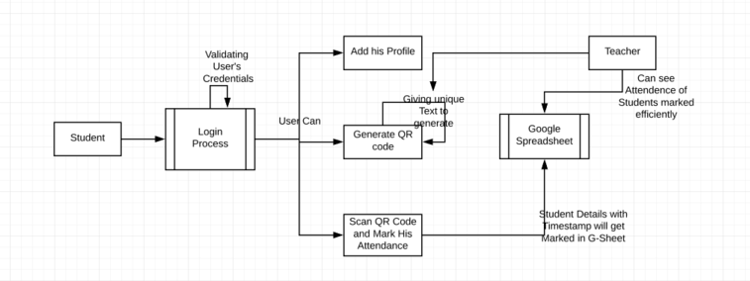

Above figure shows the flow of the app from how it starts to how it ends.

Basically, the system lies between online learning and traditional learning as a facilitation for the attendance record-keeping process, in a way that enriches the lecture time so that it can better be utilized in giving useful materials rather than wasting the time taking attendance.

**2.1.2 Hardware Interfaces**

A QR code, as shown in Fig.1 is read by an imaging device, such as a camera, and formatted algorithmically by underlying software using Reed-Solomon error correction until the image can be appropriately interpreted. Data is then extracted from patterns present in both horizontal and vertical components of the image. The QR features are listed in table 1. Figure shows a sample of an unencrypted QR code that will be needed by the proposed system.



Fig. 1. Quick Response Code

For this it is recommended to have a projector as an infrastructure in the college to display the QR Code on the screen and is ligitamate as per use.

**2.1.3 Software Interfaces**



Auth

Most apps need to know the identity of a user. Knowing a user's identity allows an app to securely save user data in the cloud and provide the same personalized experience across all of the user's devices.

Firebase Authentication provides backend services, easy-to-use SDKs, and ready-made UI libraries to authenticate users to your app. It supports authentication using passwords, phone numbers, popular federated identity providers like Google, Facebook and Twitter, and more.

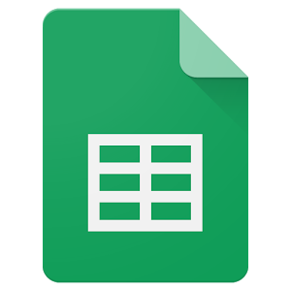

Google Spreadsheets is a Web-based application that allows users to create, update and modify [**spreadsheet**](https://whatis.techtarget.com/definition/spreadsheet)s and share the data live online. The [**Ajax**](https://searchwindevelopment.techtarget.com/definition/Ajax)-based program is compatible with Microsoft [**Excel**](https://searchenterprisedesktop.techtarget.com/definition/Excel) and CSV (comma-separated values) files. Spreadsheets can also be saved as [**HTML**](https://searchmicroservices.techtarget.com/definition/HTML-Hypertext-Markup-Language).

**2.1.4 Communications Interfaces**



Google Apps Script is a scripting language based on JavaScript that lets you do new and cool things with G Suite products like Docs, Sheets, Slides, and Forms. There's nothing to install—we give you a code editor right in your browser, and your scripts run on Google's servers

**2.2 Product Functions**

The product allows the attendee to register to the app. And save the credentials to move forward.

1)First login into the app.

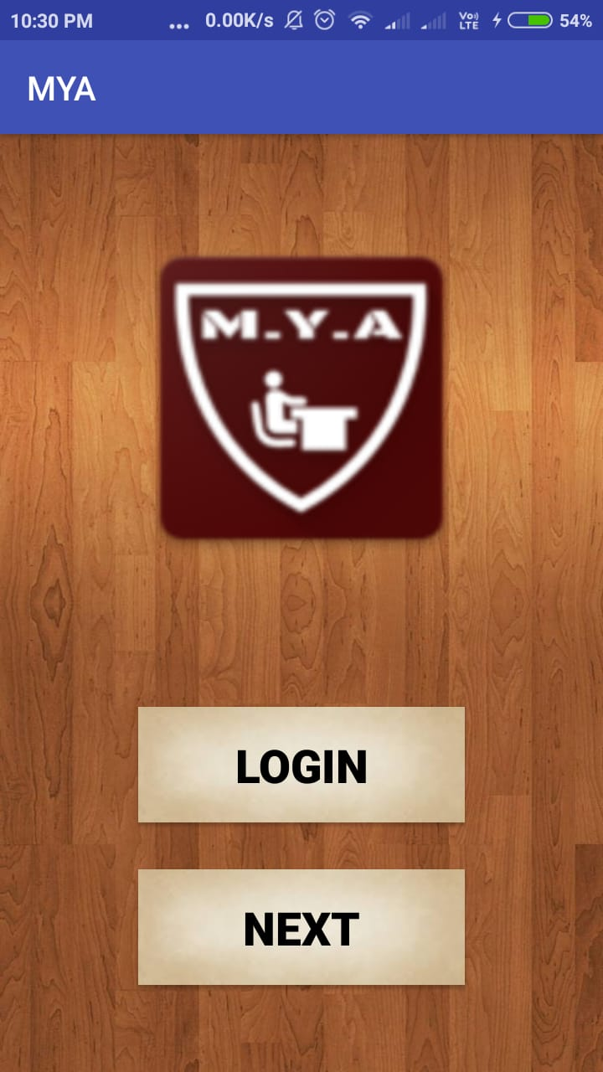

2)Select the option as per your use.

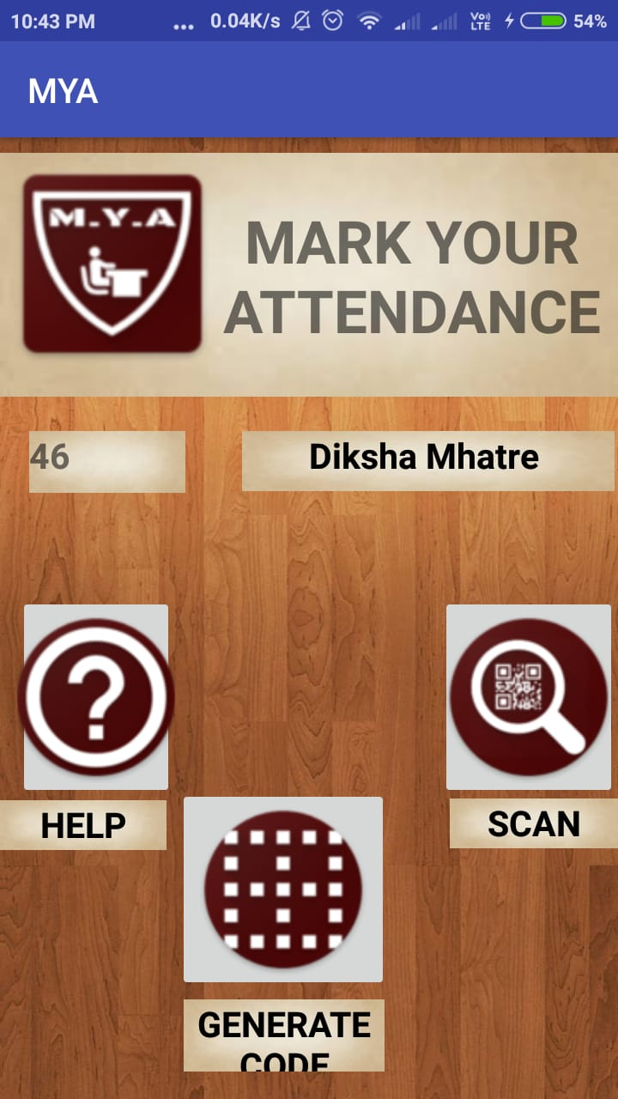

3)If the user is a teacher then generate the code by inserting the subject name,date and time specific.

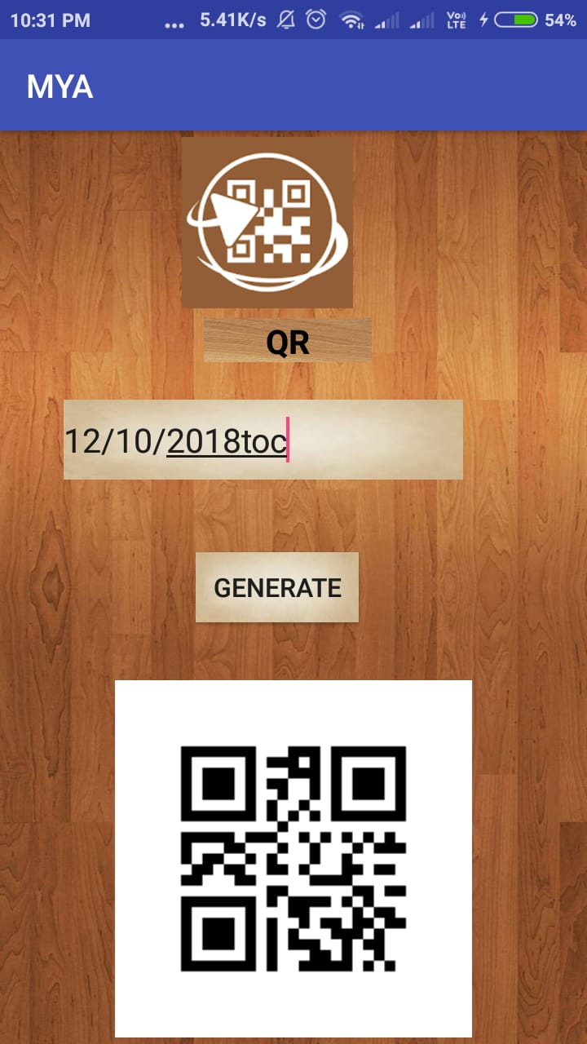

4)If the the user is a student then enter your credentials .

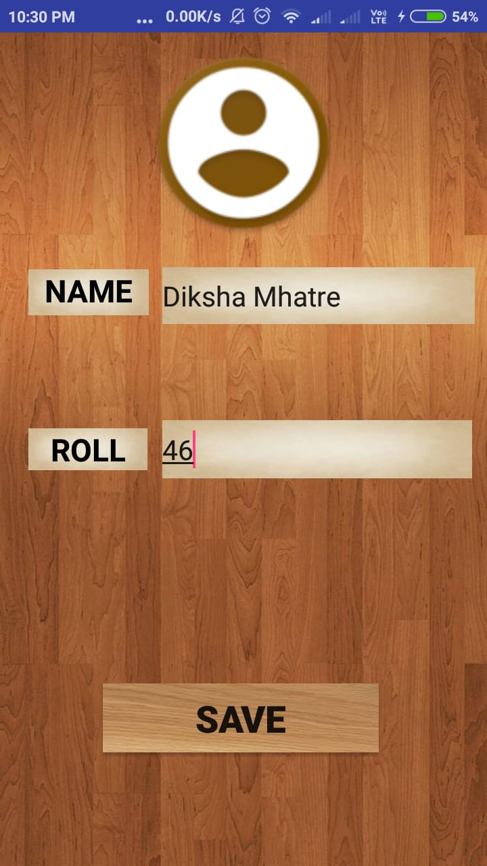

5) After this select “"Begins the scan” to scan the QR Code.

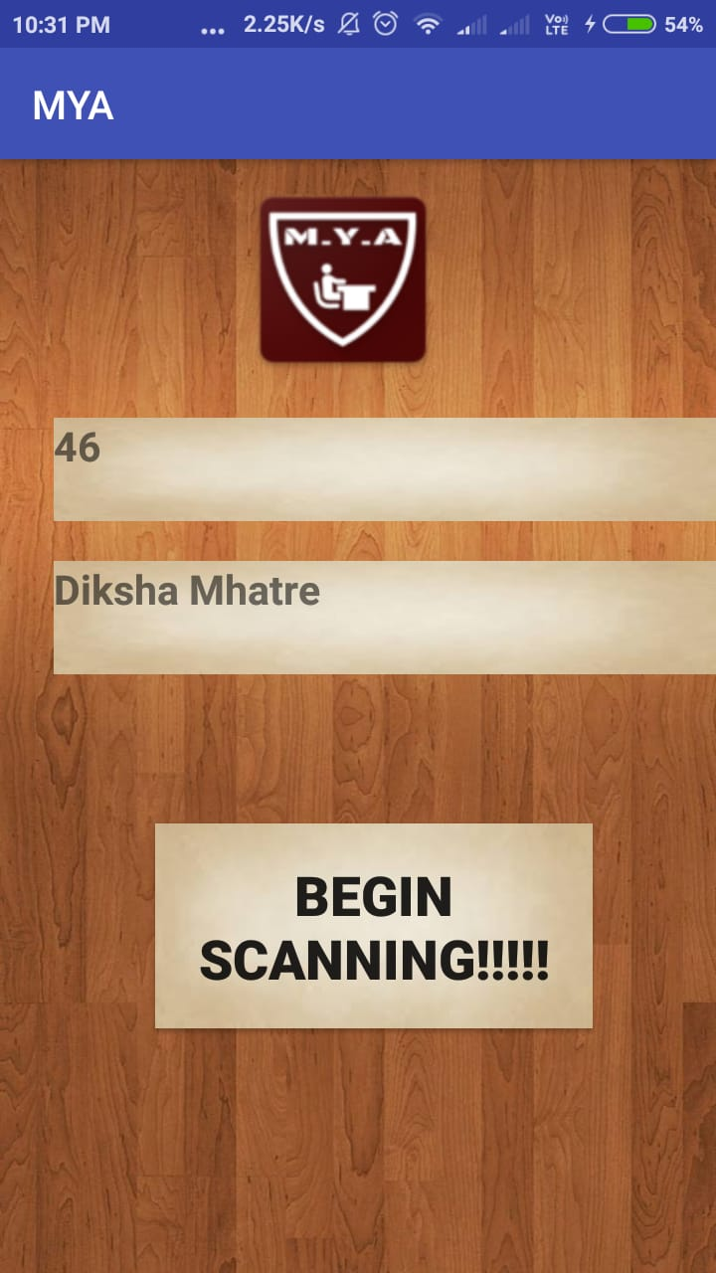

6)After the Toast message displayed “Successfully scanned” your attendance is marked correctly.

7)The user can access the help guide option to see how to use the app.

8)You can cloase the app whenever done.

**2.3 User Characteristics**

General users of the product can include the students, professors, and officials of academic institutes. For the current level of prohect.

It can be enhanced further to government and private cooperative working sectors for recording presence of the employees.

The users can access use it in specific contraints only.

**2.4 Constraints**

Provide a general description of any other items that will limit the developer's options. These can include:

(1) Applicable over Android API Jelly Bean

(2) The smart phone device must consist camera display feature.

(3) The app requires the cellular data connectivity.

(4) The product also requires the projector to display the QR Code.

(3) Once registered cannot register again.

(4) Need to install if you logout to other user.

(5) The recorded data can be only accessible responsible tea

chers provided urls.

(6) Every teacher has to be provided the url of Gsheet to access the record.

(7) The QR Code generated is read as per the admin generates each time.

Hence keeping the URL of the Gsheet Secure to avoid any malpractices.

**2.5 Assumptions and Dependencies**

Assumptions for the product is clearly the student and teacher share a college responsibility to use the product.

Assuming that every student has a smart mobile device and cellular data the product cannot be used.

Over that it also works fine low speed internet services.

Since the students may or may not have the cellular connection.

It leads to the dependency that the college provides wireless connection and provide app to the students with the projector as the infrastructure for our product functionality.

**3. Specific Requirements**

The specific requirement of the product is to provide attendance to the students.

And the teachers access the attendance in organized way.

Avoid proxy and Malpractices.

Long term data retention,.

Can act as a future evidence for events.

New automated technology to reduce the rot conventional way which consumes ample of time.

Is an integral part of every students academic performance and criteria division.

Memory provided is digital into the google servers which uses only the college data infrastructure.

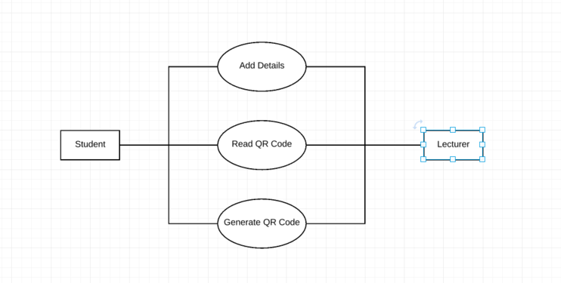

3.1Performance Requirements:

The program must be able to be run concurrently by multiple professors. During peak times of usage.

The program shall support taking roll for class sizes of up to 100 students. With a maximum class size, performance must still conform to all performance requirements.

**3.2Logical Data Requirements:**

Types of information used by various functions : The system stores the roll number, name of student, subject ,date and timestamp in google sheets. This data can be used update the daily attendance in erp system and to calculate the attendance of each student in percentage.

Frequency of use :- 11 hours daily

Accessing capabilities:- Data can be accessed by faculty of institute as per their requirements.

Data entities and their relationships:-

Entities used are:

1.Roll number of student

2.Name of student

3.Subject and date

4.Timestamp

Data retention requirements:-

Most of the universities set a norm of minimum percentage of attendance.

Hence the records of attendance need to be properly stored and analysed.

**4.0 Project Developers**

Parag Kaldate - 323028

Onkar Kumbhar - 323038

Diksha Mhatre - 323046

Neha Patil - 323054